Assignment 7

Chitresh Kumar

if(!require("pacman")) install.packages("pacman")  
pacman::p_load(tidyverse, reshape, gplots, ggmap, RStata,haven,  
 data.table,margins,pastecs,MASS,lmtest,broom,car,stargazer,sandwich,knitr)  
search()  
theme_set(theme_classic())

pub<-read_dta('pubexp.dta')  
head(pub)

## # A tibble: 6 x 3  
## ee gdp p  
## <dbl> <dbl> <dbl>  
## 1 0.34 5.67 0.36  
## 2 0.22 10.1 2.9   
## 3 0.32 11.3 2.39  
## 4 1.23 18.9 3.44  
## 5 1.81 20.9 3.87  
## 6 1.02 22.2 10.7

**PART b**

EE<-pub$ee/pub$p  
GDP<-pub$gdp/pub$p  
lm1<-lm(EE~GDP,data=pub)  
summary(lm1)

##   
## Call:  
## lm(formula = EE ~ GDP, data = pub)  
##   
## Residuals:  
## Min 1Q Median 3Q Max   
## -0.21682 -0.08804 -0.01401 0.06517 0.38156   
##   
## Coefficients:  
## Estimate Std. Error t value Pr(>|t|)   
## (Intercept) -0.124573 0.048523 -2.567 0.0151 *   
## GDP 0.073173 0.005179 14.128 2.65e-15 ***  
## ---  
## Signif. codes: 0 '***' 0.001 '**' 0.01 '*' 0.05 '.' 0.1 ' ' 1  
##   
## Residual standard error: 0.1359 on 32 degrees of freedom  
## Multiple R-squared: 0.8618, Adjusted R-squared: 0.8575   
## F-statistic: 199.6 on 1 and 32 DF, p-value: 2.65e-15

rs<-resid(lm1)  
plot(EE,rs)

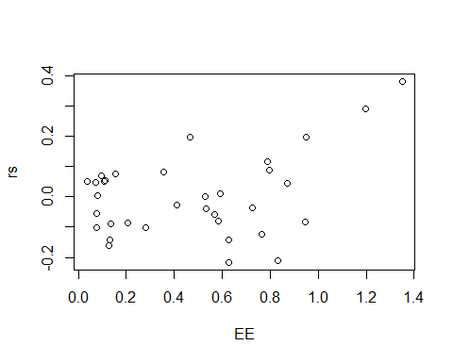

plot(lm1)

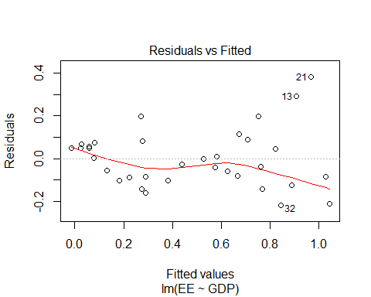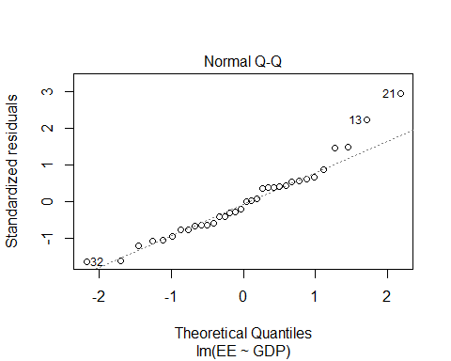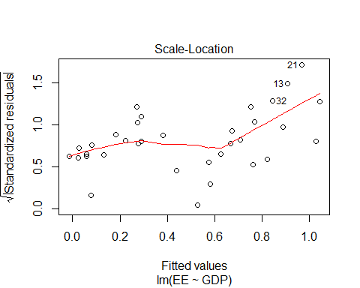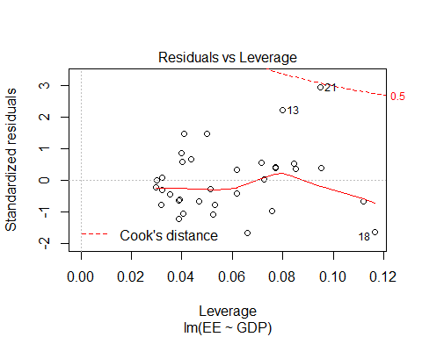

**PART c**

ressq<-rs^2  
GDP_S<-GDP^2  
lm2<-lm(ressq~GDP+GDP_S,data=pub)  
glm2<-glance(lm2)  
Rsq<-glm2$r.squared  
chisq<-34*Rsq  
pval<-1-pchisq(chisq,1)  
print(chisq)

## [1] 9.961449

print(pval)

## [1] 0.001598522

**PART d**

cov1 <- hccm(lm1, type="hc1")  
pub.HC1 <- coeftest(lm1, vcov.=cov1)  
kable(tidy(pub.HC1))

|  |  |  |  |  |
| --- | --- | --- | --- | --- |
| term | estimate | std.error | statistic | p.value |
| (Intercept) | -0.1245728 | 0.0404140 | -3.08242 | 0.0042041 |
| GDP | 0.0731732 | 0.0062116 | 11.78005 | 0.0000000 |

**PART e**

w<-1/GDP  
lmwls<-lm(EE~GDP,weights=w,data=pub)  
summary(lmwls)

##   
## Call:  
## lm(formula = EE ~ GDP, data = pub, weights = w)  
##   
## Weighted Residuals:  
## Min 1Q Median 3Q Max   
## -0.072028 -0.038561 -0.008488 0.027706 0.105415   
##   
## Coefficients:  
## Estimate Std. Error t value Pr(>|t|)   
## (Intercept) -0.092921 0.028904 -3.215 0.00298 **   
## GDP 0.069321 0.004412 15.713 < 2e-16 ***  
## ---  
## Signif. codes: 0 '***' 0.001 '**' 0.01 '*' 0.05 '.' 0.1 ' ' 1  
##   
## Residual standard error: 0.04451 on 32 degrees of freedom  
## Multiple R-squared: 0.8853, Adjusted R-squared: 0.8817   
## F-statistic: 246.9 on 1 and 32 DF, p-value: < 2.2e-16



